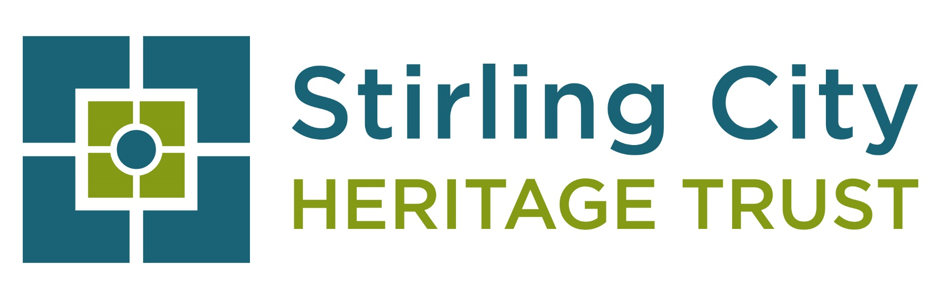
STIRLING CITY HERITAGE TRUST
APPLICATION TO BECOME A BOARD TRUSTEE

Stirling City Heritage Trust, a charitable organisation, is looking for new members to serve on its Board. As a Board member you will also be a Trustee of the charity.

This is a fantastic opportunity to use your skills and knowledge to become involved in protecting, promoting and enhancing Stirling’s architectural heritage for present and future generations and to make a positive contribution to the continued regeneration of Stirling City through its built heritage.
The Board of Directors (maximum of 11) is responsible for strategic development and operational policy, in line with the company’s charitable objectives. The day to day running of the Trust is overseen by the Trust Manager, with a total staff of seven. The organisation is based at Stirling’s charity hub, The Barracks, which is operated by The Robertson Trust.
The Trust was set up in 2004 as part of the ‘Cities Review’ and is one of 7 City Heritage Trusts operating in all of Scotland’s cities. Funding is from Historic Environment Scotland and Stirling Council.
The Trust has been instrumental in assisting with the appropriate repair and maintenance of many traditional properties in Stirling through its highly successful conservation grant schemes and has not only helped many individual private owners of residential property but also assisted in safeguarding a number of Stirling City’s iconic buildings. The Trust also operates the Traditional Buildings Health Check, a proactive maintenance scheme helping traditional building owners to understand and care for their buildings. Initially run as a pilot, the scheme is now part of the Trust’s core delivery. See our websites for details of our projects:
http://www.stirlingcityheritagetrust.org/
We seek to appoint enthusiastic, passionate and interested individuals who can contribute their time, experience and expertise, on a non-salaried basis, to our Board. In particular, we are looking for individuals who have a passion, interest and knowledge of Stirling’s traditional architecture, recognise the importance of maintenance in traditional buildings Legal

What is involved in being a Board Member?

Currently, in person Board meetings are held quarterly, usually at Old Viewforth, Stirling Council HQ with the option of winter meetings held on Zoom, if weather warnings are in place. Meetings usually start at 4pm and have an average duration of 2-3 hours. Supplementary business is generally dealt with by e-mail. However, depending on the nature of any urgent business, there may occasionally be the need to call an additional Board meeting.
We also have sub-committees and steering groups for specific purposes such as HR. There may therefore be a requirement from time to time to serve on one or more working groups, at times to suit members of the group. These are usually held during office hours.

All Board papers, where possible, are sent by email in advance of meetings, although there may be the occasional need for additional information to be tabled at the meeting. An annual timetable for future board meetings is distributed and agreed.

As a Director and Charity Trustee, in addition to attending meetings you will be expected to:

- Read papers in advance of meetings;
- Attend working group meetings, as appropriate;
- Participate in other tasks as arise from time to time, such as interviewing for staff vacancies;
- Respond to emails issued between Board meetings;
- Keep informed about the activities of partnership organisations and wider issues which may affect the work of the charity.

Who are Charity Trustees?
Charity Trustees are the people who make up the governing body and have “general control and management” of a charity. They can also be known as: directors, management committee members, or committee members.
Charity Trustees are responsible for the governance and strategy of their charity. They are responsible for making sure that their charity is administered effectively and is able to account for its activities and outcomes, both to OSCR and to the public.
In Scotland, charities are regulated by OSCR (the Office of the Scottish Charity Regulator).

What is expected of Charity Trustees?

There are four general duties which are fundamental to Charity Trustees:
- Act in the interest of the charity: Trustees should put the interests of their charity before their own interests or those of any other person or organisation.
- Operate in a manner consistent with the charity’s purposes: Trustees should carry out their duties in accordance with their governing document.
- Act with due care and diligence: Trustees should take such care of their charity’s affairs as is reasonable to expect of someone who is managing the affairs of another person.
- Ensure that the charity complies with current relevant legislation.

In addition to the general duties, a Trustee should:

- Ensure that the charity pursues its objectives, as defined in its governing document.
- Ensure its resources are used exclusively in pursuance of its objectives i.e. the organisation must not spend money on activities which are not included in its own objectives, no matter how worthwhile or charitable those activities are.
- Contribute actively to the Board of Trustees' role in giving firm strategic direction to the organisation, setting overall policy, defining goals, setting targets and evaluating performance against agreed targets.
- Safeguard the good name and values of the charity.
- Ensure the effective and efficient administration of the organisation.
- Ensure the financial stability of the organisation.
- Protect and manage the property of the organisation and ensure the proper investment of the organisation's funds.
- Represent the company at functions and meetings, as appropriate.
- Declare any conflict of interest while carrying out the duties of a Trustee.
- Be collectively responsible for the actions of the organisation and other Trustees.
- Make sure the organisation is properly insured against all reasonable liabilities.

Other duties

In addition to the above, Trustees should use any specific skills, knowledge or experiences they have to help the Board of Trustees reach sound decisions. This may involve: scrutinising board papers, leading discussions, focusing on key issues, and providing advice and guidance requested by the Board on new initiatives, or other issues relevant to the area of the organisation's work in which the Trustee has special expertise.

Board Member / Trustee person specification

In addition to being able to demonstrate your knowledge and skills in any of the required areas, to succeed in the role of a Charity Trustee you will have:

- Integrity
- A commitment to the charity and what it is seeking to achieve
- A commitment to attend meetings and devote the necessary time and effort to your duties as a Trustee
- An understanding and acceptance of the legal duties, responsibilities and liabilities of trusteeship
- Strategic vision
- Good, independent judgment
- An ability to think creatively
- An ability to work effectively as a member of a team.

What’s in it for you?

This is a fantastic opportunity to get involved in the strategic development of Stirling City Heritage Trust with the feel-good factor of knowing you are making a difference. As well as becoming involved in protecting and promoting Stirling’s heritage for present and future generations, we believe that our work can make a significant contribution to the economic prosperity of the city.

Stirling City Heritage Trust looks forward to welcoming individuals who can strengthen and lead our organisation forward in these exciting times.

SCHT Board of Trustees, February 2026

